ADVERSE CHILDHOOD EXPERIENCES
EXPANDED CONTENT

What can we as non-professionals- “just volunteers” who see children infrequently do to help? With some intention in our volunteer actions, we can do much. Christ Child programs that bring needed resources, attention in a classroom, community connections and life skills provide the ABCs of Ability, Belonging and Control to help plant the seeds of persistence and fight the effects of ACEs.

Adverse Childhood Experiences have long-lasting effects on the structure of children’s brains, their decision making and overall health. Christ Child Chapter Programs can provide the positive interactions needed to help protect children from the long-lasting effects of the serious difficulties and chaos.

The definition of a Christ Child program begins with the fact that all of us, through our CCS volunteering, can have a positive impact on our clients, that we can nurture the seeds of success in each of them. Most often, we do this by providing resources that they lack.

Serving People Where They Are
“Where people are” can also be viewed as what resources are available to them. The current term, under-resourced, refers to the lack of what a family needs to live comfortably & securely: food, clothing, health, education and skills, strong family structure, a feeling of control over their futures, income. CCS programs can provide access to these resources. Notice, money was last on the list; “the ability to leave poverty is more dependent on other resources than it is upon financial resources” (Bridges Out of Poverty, 2006).

In past seminars and in the Poverty (link to Poverty) section on this website,, we have stressed the importance of meeting our clients where they are, understanding that they most likely lack the resources necessary for a comfortable and secure life such as food, adequate shelter, control over their own lives, a good education, a good night’s sleep in their own bed and access to books.

One resource we seldom consider is a safe, trauma-free childhood. Researchers from behavioral scientists to social workers have sought an understanding of the causes and consequences of poverty, inequality and the impact of poverty on child development. Clearly, ACEs contribute to this impact.

Adverse Childhood Experiences
A Kaiser Permanente study conducted from 1995 to 1997, with two waves of
data collection identifies Adverse Childhood Experiences, or ACEs as being instrumental in future struggles. These finding have been supported by many subsequent studies. ACEs are negative experiences that are categorized into three groups: abuse, neglect and household challenges.

All ACE questions refer to the respondent’s first 18 years of life.
Abuse
  - Emotional abuse: A parent, stepparent, or adult living in your home swore at you, insulted you, put you down, or acted in a way that made you afraid that you might be physically hurt.
  - Physical abuse: A parent, stepparent, or adult living in your home pushed, grabbed, slapped, threw something at you, or hit you so hard that you had marks or were injured.
  - Sexual abuse: An adult, relative, family friend, or stranger who was at least 5 years older than you ever touched or fondled your body in a sexual way, made you touch his/her body in a sexual way, attempted to have any type of sexual intercourse with you.

Household Challenges
  - Mother treated violently: Your mother or stepmother was pushed, grabbed, slapped, had something thrown at her, kicked, bitten, hit with a fist, hit with something hard, repeatedly hit for over at least a few minutes, or ever threatened or hurt by a knife or gun by your father (or stepfather) or mother’s boyfriend.
  - Substance abuse in the household: A household member was a problem drinker or alcoholic or a household member used street drugs.
  - Mental illness in the household: A household member was depressed or mentally ill or a household member attempted suicide.
  - Parental separation or divorce: Your parents were ever separated or divorced.
  - Incarcerated household member: A household member went to prison.

Neglect
  - Emotional neglect: No one in your family helped you feel important or special, you felt unloved, your family was not a source of strength and support, weak family structure.
  - Physical neglect: No one took care of you or protected you, your health needs were ignored, you didn’t have enough to eat, your parents were too drunk or too high to take care of you, and you had to wear dirty clothes, you had an unstable housing situation.
ACEs are common across all populations. Almost two-thirds of study participants reported at least one ACE, and more than one in five reported three or more ACEs. Although ACEs occur across economic lines, those in poverty tend to experience them more often and (this is key) have less access to resources to help them work through the issues and build resilience to deal with them.

The ACE score in the study is the total sum of the different categories of ACEs reported by participants. Study findings show a relationship between ACEs and negative health and well-being outcomes. In other words, as the number of ACEs increases so does the risk for negative outcomes. Discover your own ACEs score with the ACE test (link to test).

Remember this, too: ACE scores don't tally the positive experiences in early life that can help build resilience and protect a child from the effects of trauma. Having a grandparent who loves you, a teacher who understands and believes in you, or a trusted friend you can confide in may mitigate the long-term effects of early trauma, psychologists say.

"There are people with high ACE scores who do remarkably well," says Jack Shonkoff, a pediatrician and director of the Center on the Developing Child at Harvard University.
Resilience, he says, builds throughout life, and close relationships are key. Recent research also suggests that for adults, "trauma informed" therapy — which can center on art, yoga or mindfulness training — can help.

Childhood Trauma
Oprah Winfrey researched a story for 60 Minutes about ACEs, a topic she discovered while working with a psychologist, Dr, Bruce Perry, a world-renowned expert in the field who has treated survivors of high-profile events like the Columbine shooting.

Oprah realized the traumas of her youth – physical punishment and sexual abuse – were Adverse Childhood Experiences. Watch her speak about the impact of ACEs. https://www.youtube.com/watch?v=dF20FaQzYUI

ACEs – A Lasting Impact
The effects of ACE’s follow a typical trajectory: Children experiencing ACE’s develop PTSD-like symptoms: social, emotional and cognitive impairment. At this point, in childhood, if they get help, if they have a support system, if they have help building coping mechanisms, they can get through it. If not, most often, they go on to display high risk behaviors in adolescence such as drug and alcohol use, violent or criminal behavior, risky sexual behaviors, depression and suicide attempts. In adulthood, they experience more chronic disease, obesity, disability and social problems than the average adult.

When we consider “where our clients are,” we must also consider childhood traumas they may have endured.

ACEs have detrimental effects on a child’s future, well into adulthood and a likely premature death. Some researchers refer to the result as toxic stress that literally hampers healthy physical, mental and emotional development

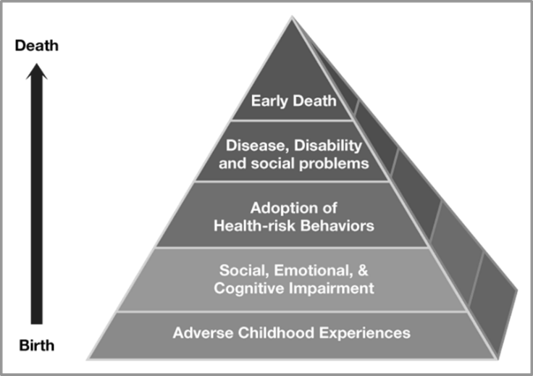

Study findings show a direct relationship between ACEs and negative health and well-being outcomes; as the number of ACEs increases so does the risk for negative outcomes. When they occur in childhood, they impact the critical formation time of brain synapses. Brains adapt to the realities of their environment and perceptions of self and others are skewed.

Mitigating the Effects of Aces Through Resilience Building
What can we as non-professionals- “just volunteers” - who see children infrequently do to help? With some intention in our actions, we can do much. For example, a Spelman College student described a project she did on her campus where she literally said to female students, “Do you know you are beautiful?” and recorded their reactions. We all know we love a compliment, but scientists tell us that in receiving a sincere compliment we trigger the ventral striatum, the part of the brain where the sense of reward and perhaps more importantly for our purpose, sense of safety are processed. We trigger the reward system in someone else’s brain and boost our own happiness. So, there is a reward for volunteers too! There is also a known self-fulfilling prophecy of the positive rewards of compliments that increase gratitude, liveliness and connection between people.

William James, the father of psychology said, “Our deepest craving is to be appreciated.”

How can the impact of ACEs be mitigated? As Oprah Winfrey told her story on CBS, the reason she was able to move past the trauma of both sexual and physical abuse, what she calls “the hole in her soul,” were people in her life – especially teachers – who said “You’re ok, you are strong, you are loved.” You need to feel you are better, stronger than the circumstances of the childhood that damaged your sense of self. When the person you love most hits you, when your father disappears, when your mother can’t feed you, you need some proportional positive experiences to build resilience and grit.

Every Kids is One Caring Adult Away from Being a Success
In the book The Deepest Well: Healing the Long-Term Effects of Childhood Adversity, Dr. Nadine Burke Harris, a San Francisco pediatrician, outlines much of the current research on ACE’s and her experience that many day to day health problems and difficulties coping displayed by her patients and their families could be traced to the ACE experiences in their lives. She talked about the importance of professional intervention by psychologists and psychiatrists.

(Mary Virginia Merrick was very astute in recognizing the need for professionals. The Washington DC chapter continues to support education of child psychologists and in their work local schools.)

Dr. Harris also talked about and arranged for some very practical programs in her neighborhood clinic, the types of programs that go on in various Christ Child Chapters: combatting isolation and building connections like Milwaukee’s Second Saturday Program; a program to teach positive parenting to help decrease violence in the home in Toledo; and things we may take for granted because they are so logical to us such as establishing regular sleep patterns, regular exercise, healthy food choices and basic cooking skills. Extremely important are the expressions of affection and security as well as the knowledge base built by being exposed to many words that come with cuddling and regularly reading aloud to children.

These are ways we can be intentional about how we boost a child’s esteem by helping them be capable in a school subject. These are things we can be involved in and work to promote without a PhD or MD.

Ability, Belonging and Control
You may remember the presentation (Link to Deevers’ Seeds to trees Slides) by Matt Deevers in Milwaukee at Convention 2018. In his presentation entitled Seeds to Trees, (link to Seeds to Trees text)) he talked about 3 areas that, through his experience as an educator and his education in the area of positive psychology, are keys to cultivating persistence for everyone - not just children.

Those areas are Ability, Belonging and Control. Think of a 3-legged stool. These ABC's supply balance, strength and structure to support a positive identity and enough security to risk persistence. ACE's are threats to keeping the ABC's in balance.

- A sense of ABILITY gives self-confidence and willingness to try and learn.

- A sense of BELONGING fills our need for community bonds and connections. It allows for commitment and cooperation.

- A sense of CONTROL nurtures our drive for freedom and feeling like we have the power to make a choice. People who have the ability to make choices in a situation and who are in control feel ownership and are willing to engage.

These things are all very important in the school settings we often find ourselves in, but also in many areas of life and through adulthood. Just like ACE's can have long lasting negative effects, a strong presence of ABC's can help with the ability to be persistent when life gets difficult

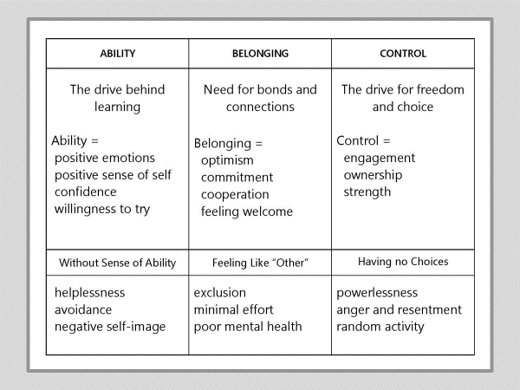

Christ Child Chapters can be intentional about their focus on reinforcing and strengthening Ability, Belonging or Control. Programs can ensure that they are intentional in efforts to build up in these areas in simple ways such as:
- picking one of a selection of a reading session follow up crafts;
- letting children select their own books and talk about why it interested them;
- mentioning strengths you see in a child such as ability to read aloud, color, or sing; making children feel welcome and valued.

Your chapter can apply the ABC paradigm to your programs using the worksheet created by Matt Deevers, Seeds to Trees: Cultivating Persistence in Ourselves, Our Chapters and Our Programs (link to worksheet).

Fostering Resilience
Dr. Kenneth Ginsburg, a pediatrician specializing in Adolescent Medicine at the Children's Hospital of Philadelphia developed a similar paradigm for building resilience in children. He also serves Philadelphia’s homeless youth as Director of Health Services at Covenant House Pennsylvania. The theme that ties together his clinical practice, teaching, research and advocacy efforts is that of building on the strength of teenagers by fostering their internal resilience. His goal is to translate the best of what is known from research and practice into practical approaches parents, professionals and communities can use to prepare children and teens to thrive.
Dr. Ginsburg believes that young people live up or down to expectations we set for them. They need adults who believe in them unconditionally and hold them to the high expectations of being compassionate, generous, and creative. His Fostering Resilience model http://www.fosteringresilience.com/ (link to his website) includes

The 7 Cs: The Essential Building Blocks of Resilience:

- Competence: When we notice what young people are doing right and give them opportunities to develop important skills, they feel competent. We undermine competence when we don't allow young people to recover themselves after a fall.
- Confidence: Young people need confidence to be able to navigate the world, think outside the box, and recover from challenges.
- Connection: Connections with other people, schools, and communities offer young people the security that allows them to stand on their own and develop creative solutions.
- Character: Young people need a clear sense of right and wrong and a commitment to integrity.
- Contribution: Young people who contribute to the well-being of others will receive gratitude rather than condemnation. They will learn that contributing feels good and may therefore more easily turn to others and do so without shame.
- Coping: Young people who possess a variety of healthy coping strategies will be less likely to turn to dangerous quick fixes when stressed.
- Control: Young people who understand privileges and respect are earned through demonstrated responsibility will learn to make wise choices and feel a sense of control.

Christ Child Society programs provide excellent opportunities to provide unconditional support for the children we serve.

More resources about ACEs and building resilience can be found here (link to ACEs Resource List)

Build self-esteem in your young clients
and encourage reading with the
NCCS bookmark (link to bookmark in English and Spanish.

